Maximum Power Transfer

Verification Through a Graph

By putting respective values of R2 and Checking each value of current through the resistor R2 and calculating its power through that resistor.

For 10 V Source: -

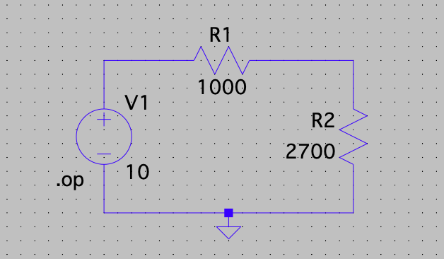

Table: -

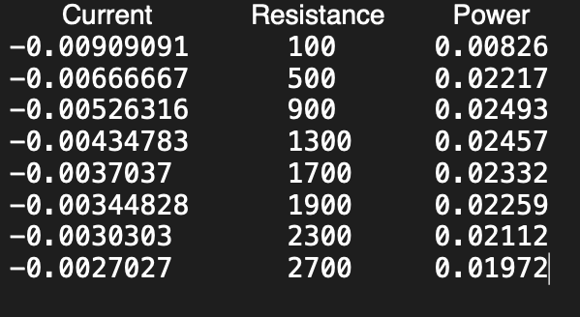

For 20 V Source : -

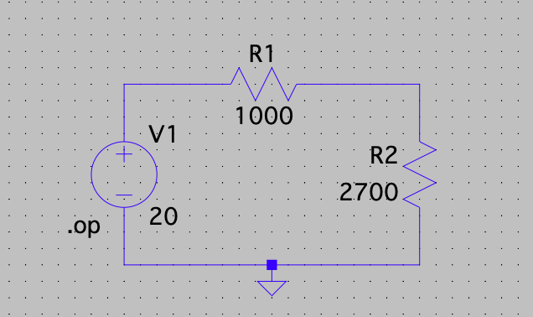

Table : -

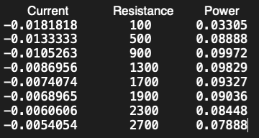

MERGING BOTH THE GRAPHS:

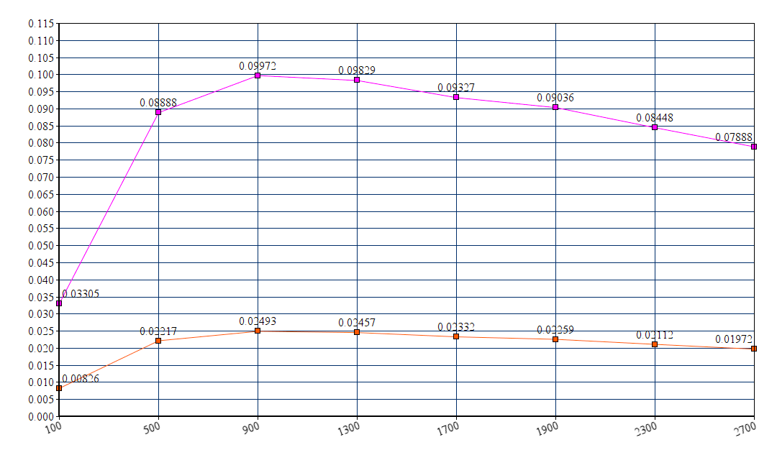

-------------------Power on Y-Axis and Resistance on X-Axis---------------------